Step-by-Step Implementation

Step 1: Login to Jenkins
- Open the Jenkins web interface.
- Log in using the admin credentials.
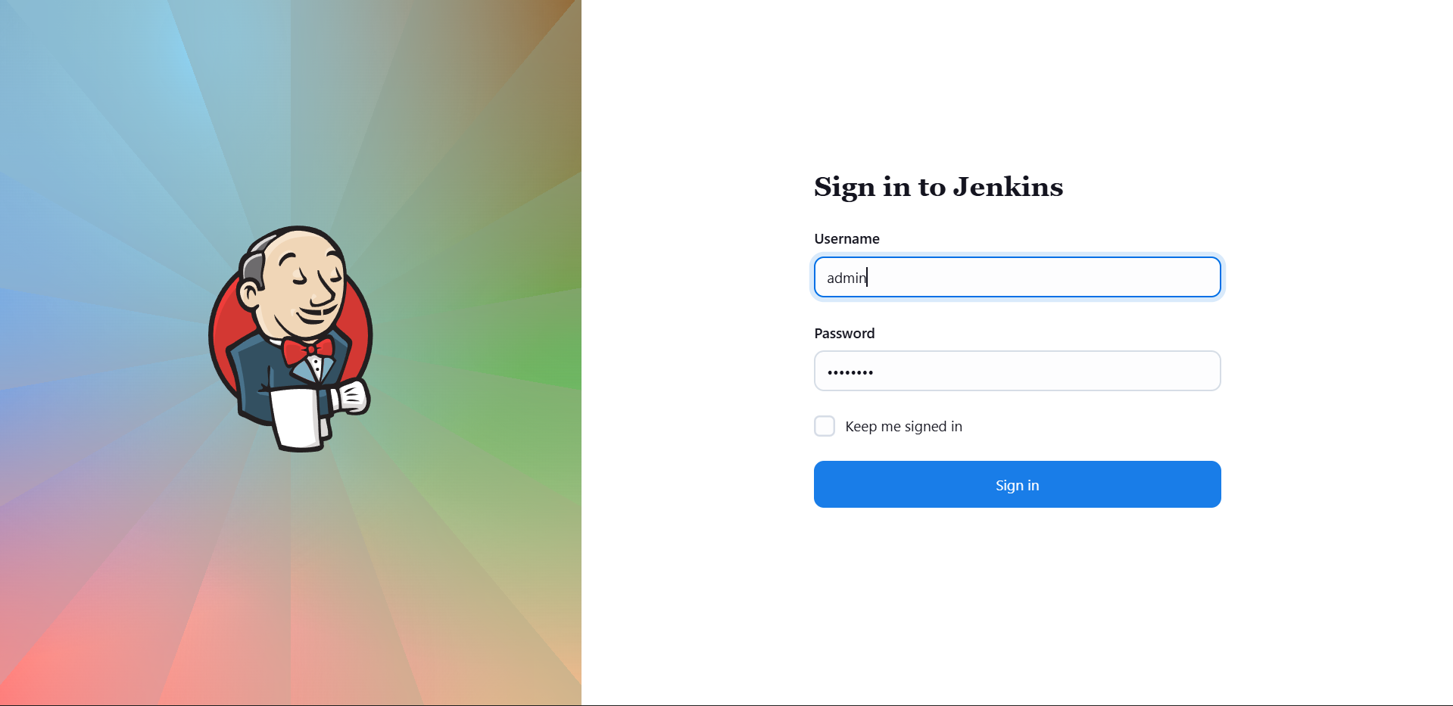
- Ensure successful access to the Jenkins dashboard.

Step 2: Install Matrix Authorization Strategy Plugin
- Navigate to Manage Jenkins from the dashboard.
- Click on Plugins.
- Go to the Available Plugins section.
- Search for Matrix Authorization Strategy.
- Select the plugin and click Install.
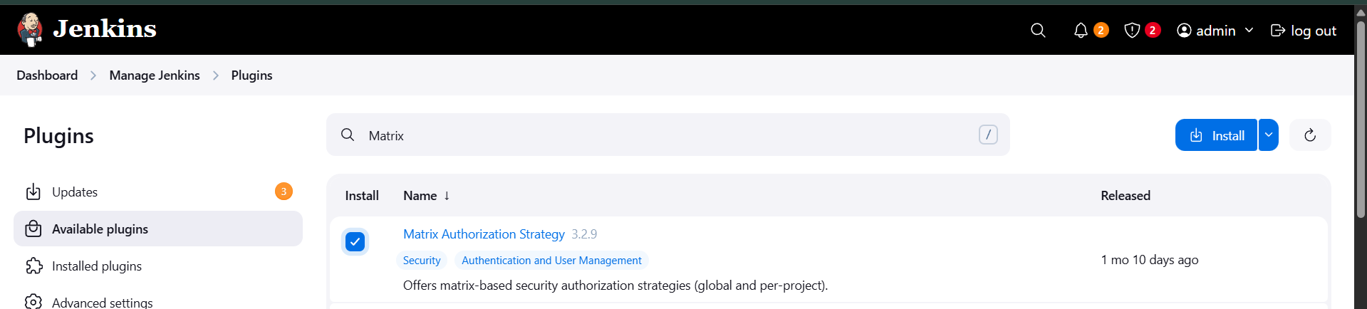
- Wait until the installation is completed successfully.

Step 3: Restart Jenkins
- After plugin installation, Jenkins prompts for a restart.
- Perform a Safe Restart to apply the plugin changes.
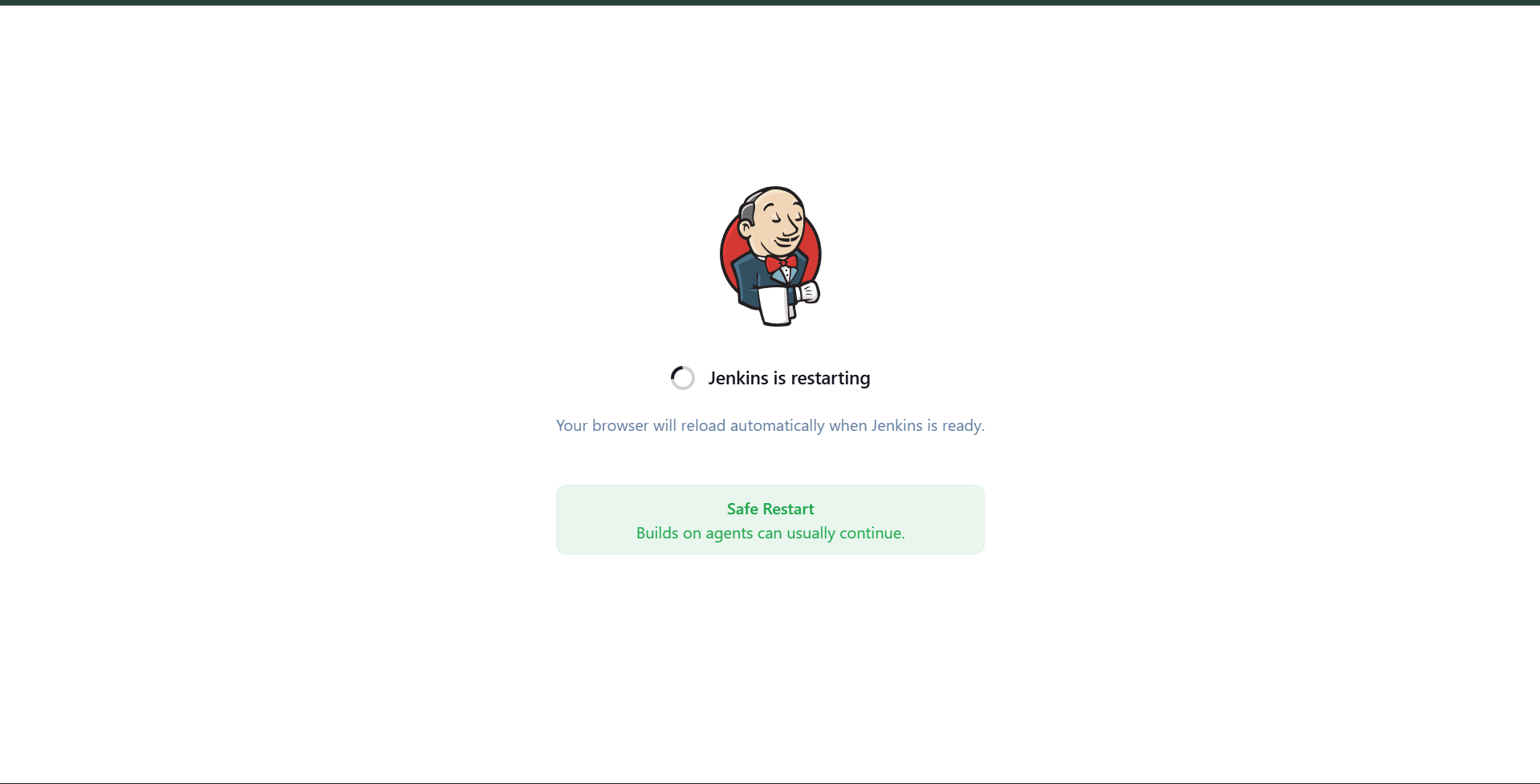
- Wait until Jenkins restarts and becomes accessible again.
- Log in again as admin after restart.

Step 4: Verify Security Configuration
- Go to Manage Jenkins → Security.
- Confirm that Matrix-based security is available as an authorization strategy.
- This ensures Jenkins supports both global and project-level permission management.

Step 5: Open Job Configuration
- From the Jenkins dashboard, open the existing job Packages.
- Click on Configure.
- Navigate to the General section.

Step 6: Enable Project-Based Security
- Check the option Enable project-based security.
- Under Inheritance Strategy, select:
  - Inherit permissions from parent ACL
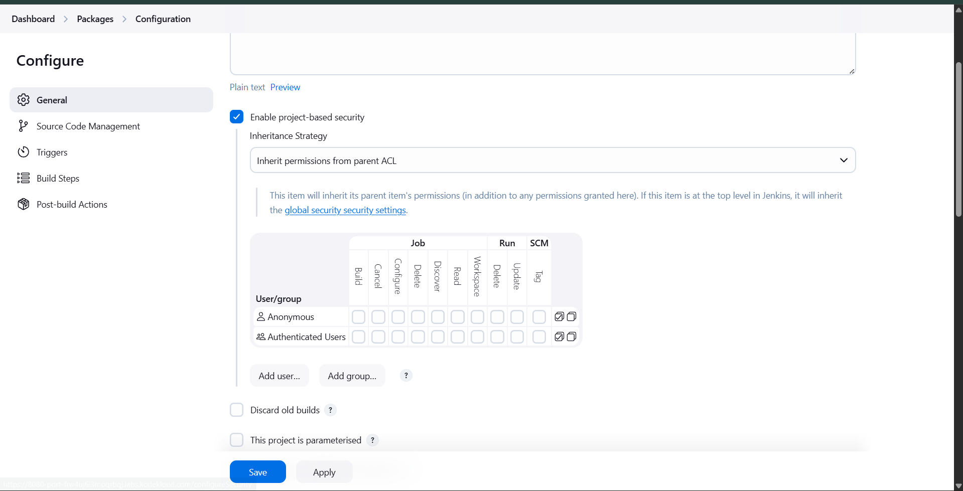
- This ensures the job inherits global permissions while allowing custom overrides.

Step 7: Grant Permissions to User sam
- Click Add user and enter sam.
- Assign the following Job-level permissions:
  - Build
  - Configure
  - Read
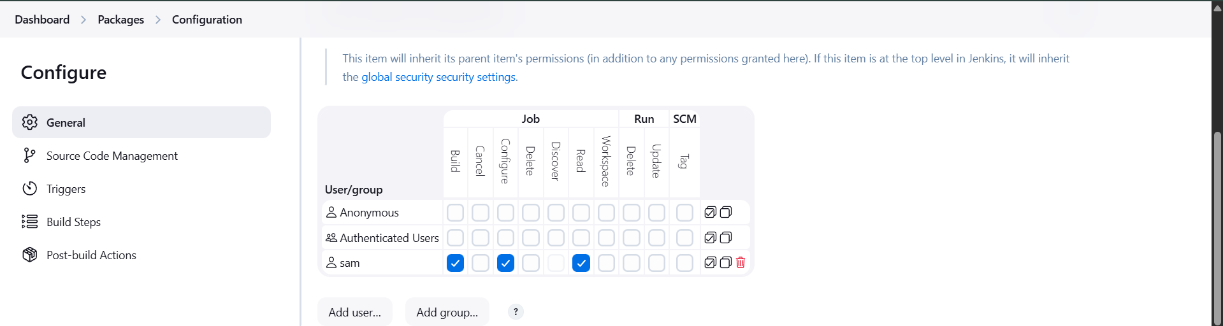
- Do not grant any additional permissions beyond the requirement.

Step 8: Grant Permissions to User rohan
- Click Add user and enter rohan.
- Assign the following permissions:
  - Build
  - Cancel
  - Configure
  - Read
  - Update
  - Tag
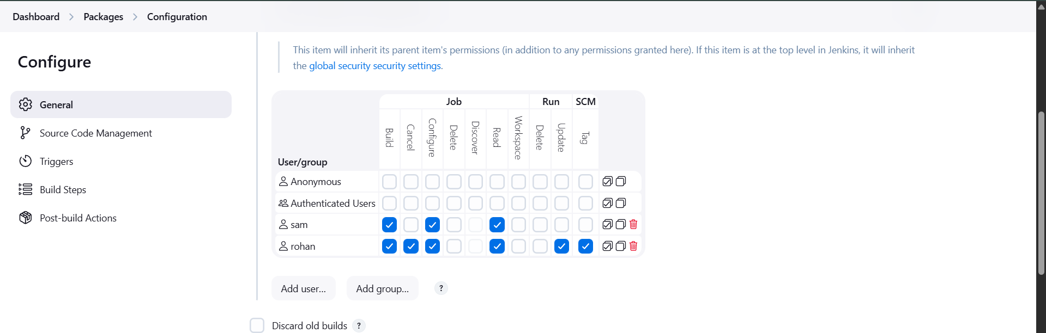
- Ensure permissions match exactly as per requirement.

Step 9: Save Configuration
- Click Save at the bottom of the job configuration page.
- Confirm that the settings are applied successfully.

